Introduction to Network hardware
- Draw a labeled diagram of a typical home Wi-Fi setup showing a modem, router, switch, access point, and at least two devices (like a laptop and smartphone) connected to the network.
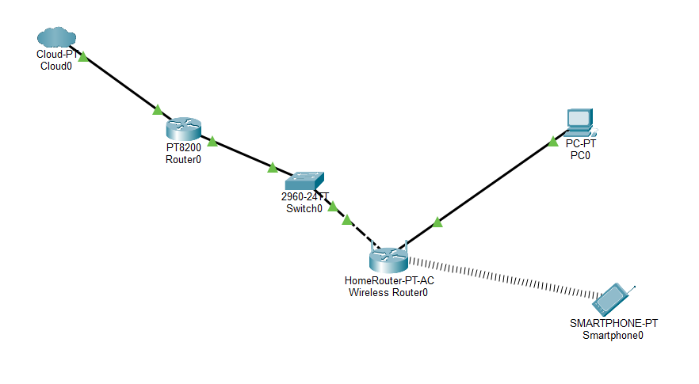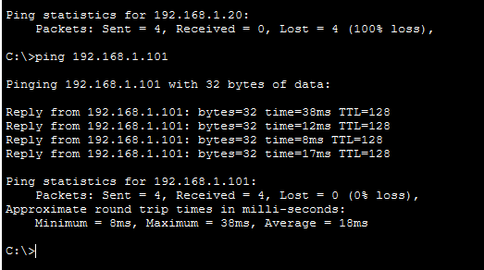
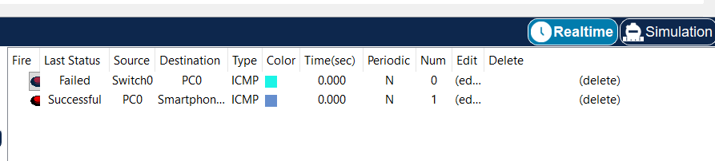

Step1: PT Router
- Router0 -> config
GigabitEthernet0/0
- IP: 10.0.0.1
- Mask: 255.0.0
- Port: ON
GigaEthernet0/1
- IP: 192.168.1.1
- Mask: 255.255.255.0
- Port: ON
It connects the home network to the internet.
Step2: Switch
- No configuration required
- It only connects multiple wired device and transfer data
Step3: Wireless Router
- Wireless Router -> GUI -> Setup
- Router IP: 192.168.1.2
- Subnet Mask: 255.255.255.0
- DHCP: Enable
Step4: Wireless Settings
- Wireless Router -> Basic Setup
- Internet Connection Type: Automatic Configuration (DHCP)
- Router IP: 192.168.1.2
- Subnet Mask: 255.255.255.0
- DHCP Server: Enabled
- Wireless -> Basic Wireless Settings
- Network Mode: Auto
- SSID: HomeWiFi
- SSID Broadcast: Enabled
- Wireless Security
- Authentication: Disabled
Step5: PC0 Configuration
- PC0 -> Desktop -> IP Configuration
- IP Configuration: Static
- IP: 192.168.1.10
- Subnet Mask: 255.255.255.0
- Default Gateway: 192.168.1.1
Step6: Smart Phone
- Port Status: ON
- SSID: HomeWiFi
- Authentication: Disabled
- IP Configuration: DHCP
- Default gateway: 192.168.1.2

- List the main function of each networking hardware device: modem, router, switch, access point, and network cable. For each, give a real-life example of where you might see or use it (for example, 'router: at home to share internet').
Table 1. Hardware Device
Device | Main Function | Real-Life Example
Modem | Connects your home to the Internet. | Used at home to get Internet from the ISP.
Router | Shares the Internet with many devices. | Used at home to connect phones, laptops, and TVs to the Internet.
Switch | Connects many wired devices together. | Used in offices or computer labs to connect computers.
Access Point (AP) | Gives Wi-Fi to wireless devices. | Used in schools, malls, and offices to provide Wi-Fi.
Network Cable (Ethernet Cable) | Connects devices using a wire. | Used to connect a PC to a router or switch.

- Take photos or find images online (with source links) of at least three types of network cables (such as Ethernet, coaxial, fiber optic) and write one line describing where each is commonly used.
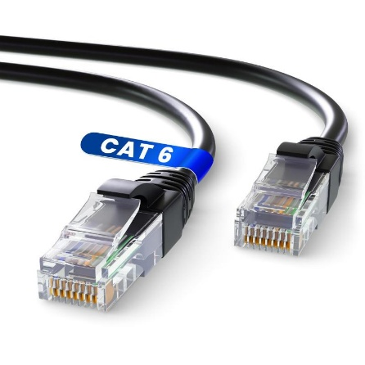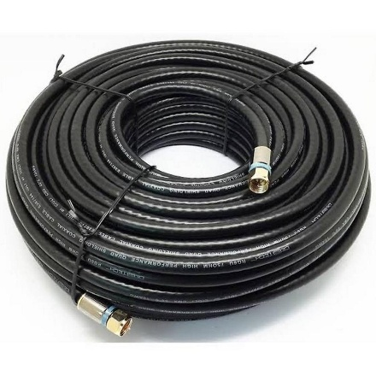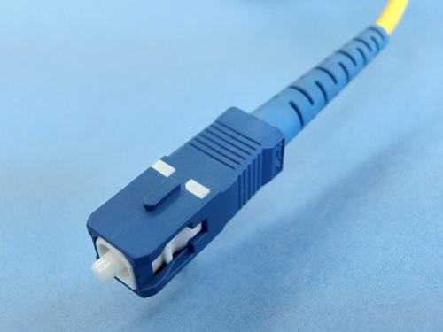
Ethernet Cable Coaxial Cable Fiber Optic Cable

Table 2: Cables
Cable Type | Description | Use
Ethernet Cable | A twisted-pair cable used to connect network devices. | Connects computers, routers, and switches in homes and offices.
Coaxial Cable | A cable with a single copper wire and protective shielding. | Used for cable TV, broadband Internet, and CCTV systems.
Fiber Optic Cable | A cable made of thin glass or plastic fibers that carries data as light. | Used for high-speed Internet and long-distance communication.

- Create a comparison table listing at least four differences between a router and a switch, including their main use, typical location, and how they handle data.
Table 3: Router vs Switch
Router | Switch
Shares the Internet with multiple devices. | Connects multiple devices in the same network (LAN).
Used in homes, offices, and schools. | Used in offices, schools, and computer labs.
Uses IP addresses to send data between networks. | Uses MAC addresses to send data to the correct device.
Connects different networks (LAN to Internet). | Connects devices within one local network (LAN).

